**PROJECT REPORT TEMLATE**

Designing Professional Business Cards

1. **INTRODUCTION**
   1. **over view**

The "Designing Professional Business Cards for Effective Networking" project focuses on creating visually appealing and impactful business cards that leave a lasting impression and facilitate meaningful connections in the business world. A well-designed business card is an essential tool for networking, showcasing professionalism, and conveying key information succinctly.

* 1. Purpose
* Small and Convenient
* Affordable Advertisement
* Give A visual aid to Remember your business
* Business cards are a vital networking tool
* Business Cards Create and professional Image credible

1. **Problem Definition & Design Thinking**
   1. **Empathy Map**

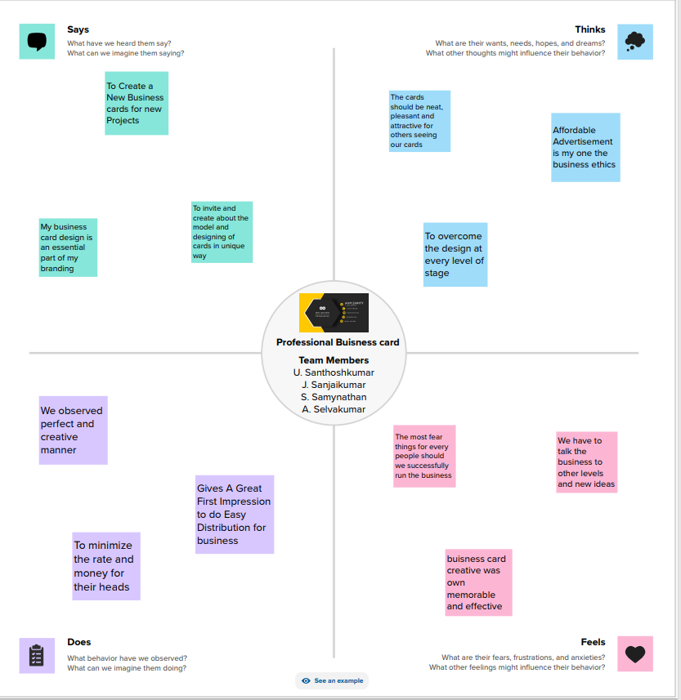

**2.2Ideation &Brainstorming Map**

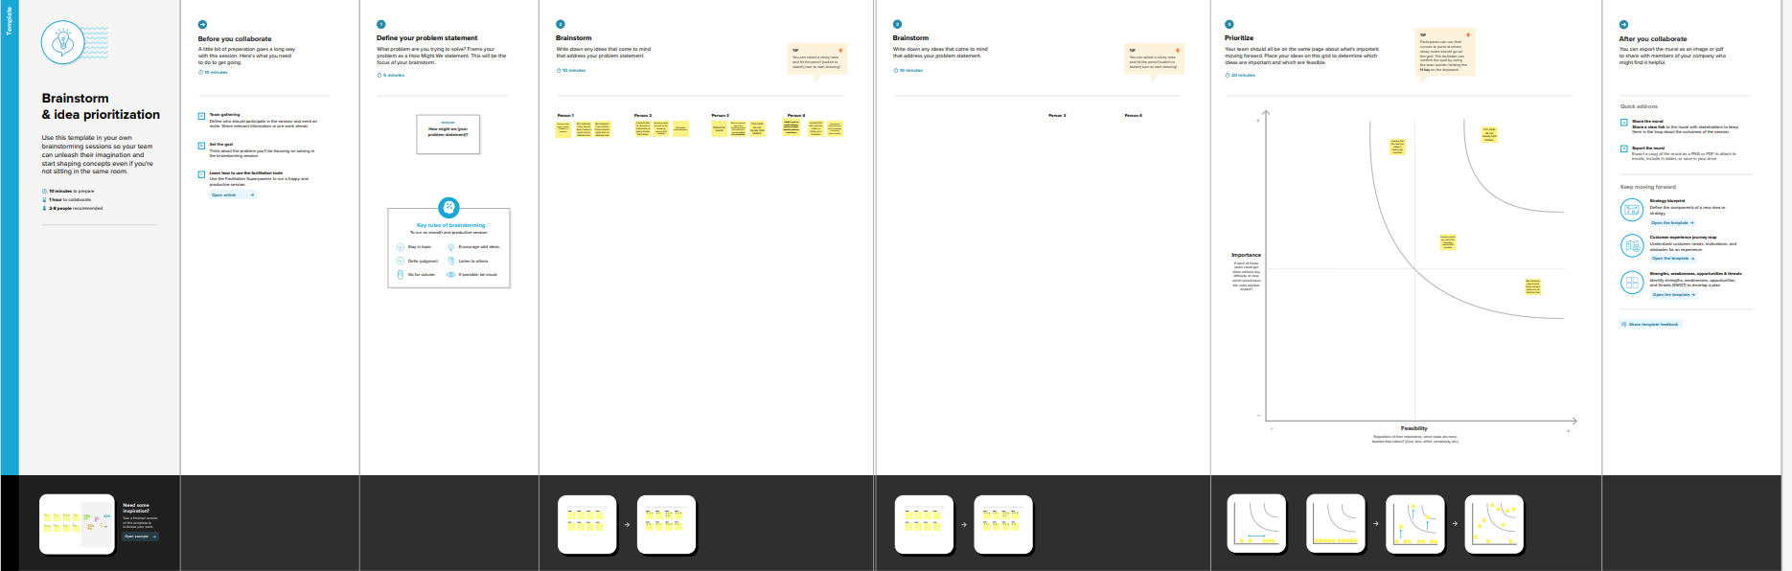

1. **RESULT**



**Business Card**

1. **ADVANTAGES & DISADVANTAGES**

**ADVANTAGES**

**DISADVANTAGES**

**APPLICATIONS**

**CONCLUSION**

* Canva is very simple to use and user friendly
* Canva provides social media templates
* Canva offers a professional look
* Team access
* As well as million of image
* The free version is limited
* Unique elements cannot be created
* limited export setting s
* Alignment concerns
* Unable to move one design to another design
* We create a canva account
* Choose our design type
* And we used business card template
* we uploaded our background image
* we used uploading photos, and adding text, and used to editing elements, and change fonts
* Added to the women icon, flower design of corner.
* we created to business card
* Finally, we downloaded a design

People in our team worked together to make a business card on the topic " Designing professional business card " through this, a company's advertisement can be brought to the door of the card. canva is an essential tool for most business. It is easy to use offers a wide range of templates, its affordable, customizable and helps business with their branding. Graphic designing can be learned through this project.